The Minnesota Department of Corrections often creates reports for the Minnesota State Legislature to identify the importance of funding programs that are known to improve public safety. The following data was presented in one such report.

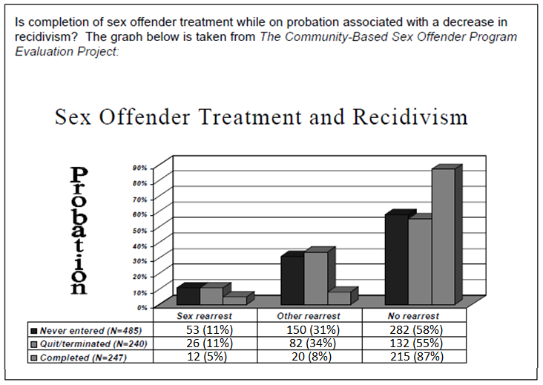

Research Question: Is the status regarding their completion of a sex offender treatment program while on probation associated with a change in three categories of recidivism?

Complete the following

* Put this data into the correct format for an analysis
* Obtain a mosaic plot and contingency table for this data
* Obtain a p-value for the Pearson’s Chi-Square Test of Independence

|  |  |
| --- | --- |
| Correct Data Structure | Sample JMP Output |
|  |  |

Complete the following

1. Obtain the desired output in JMP (Mosaic Plot, Contingency Table, and output from Chi-Square Test of Independence. (5 pts)

*Delete my sample output and place your output here...*

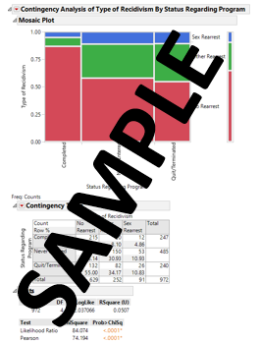

1. Use the mosaic plot to comment on the following statement. (5 pts)

*“The sexual treatment program appears to be working”*

My answers here….

1. Use the mosaic plot to comment on the following statement. (4 pts)

*“Those that quit or were terminated from the sexual treatment program   
benefited from the program. ”*

More of my answers...

Reconsider the research question under investigation.

Research Question: Is the status regarding their completion of a sex offender treatment program while on probation associated with a change in three categories of recidivism?

1. Make the appropriate statistical decision. (Bold/Highlight the correct decision). (2 pts)

Decision: If the p-value < 0.05, then data is said to support the research question.

* Data supports research question
* Data does not support research question

1. Write a final conclusion in laymen’s terms. (4 pts)

Consider the following mosaic plot that is comparing only two categories (those that never entered against those that Quit/Terminated).

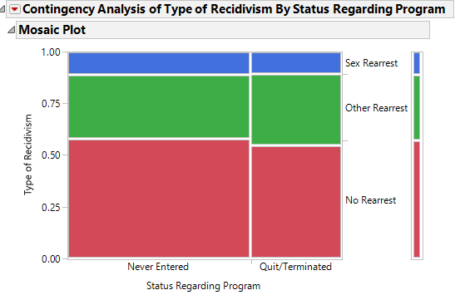

1. Would the p-value associated with this plot be higher or lower than the p-value obtained above (when using all three categories). Explain. (5 pts)